**GIT REMOTE TO LOCAL MACHINE**

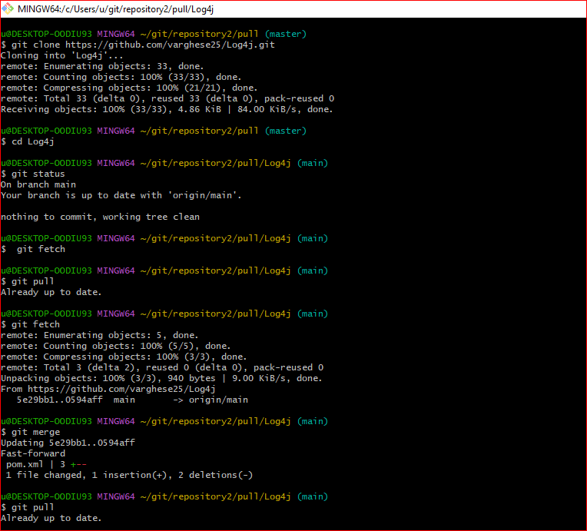Git pull from Remote (GitHub) To LocalMachine

1. Clone: Remote & LocalMachine  
    $git clone https://github.com/varghese25/Log4j.git   
   Remote and Local Machine using Remote URL Example(<https://github.com/varghese25/Log4j.git>)
2. LocalMachine created folder Pull C:\Users\u\git\repository2\pull  
   Cd Log4j (we all files downloaded)
3. Git fetch $ git fetch (Anything Changes made in GitHub working file ex pom.xml whitespace removed and Committed in the remote) notify in the localMachine next, I have to give merge.
4. Git merge is to merge with localMachine which is committed in the remote
5. Git pull says remote changes updated in localMachine
6. Git Status   
   u@DESKTOP-OODIU93 MINGW64 ~/git/repository2/pull/Log4j (main)

$ git status

On branch main

Your branch is up to date with 'origin/main'.

nothing to commit, working tree clean

**Video Reference:**  
 https://www.youtube.com/watch?v=KmagW60Li-o

**GIT LOCAL TO REMOTE MACHINE**

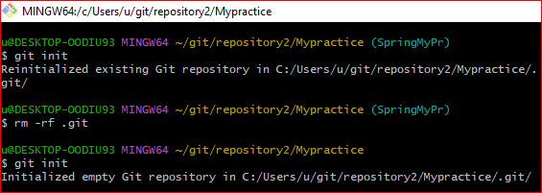

Screenshot for Reference

Before proceeding to local Machine to (Git) Remote machine issue occurs like (Reinitialized existing Git repository in C:/Users/u/git/repository2/Mypractice/.git/.Fellow the command.  
$ rm -rf .git  
  
Video Reference:  
 https://www.youtube.com/watch?v=mZWHxW6R04M  
  
Then Proceed Local to remote file uploading. GIT Push From Local to Remote   
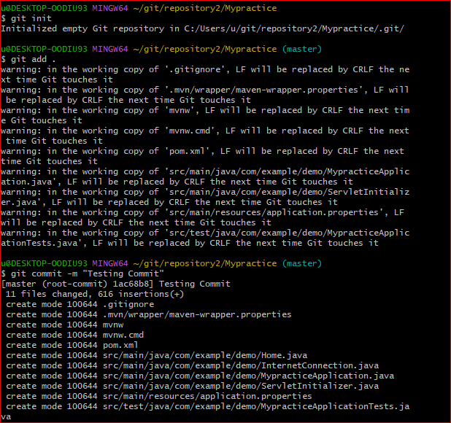  
  
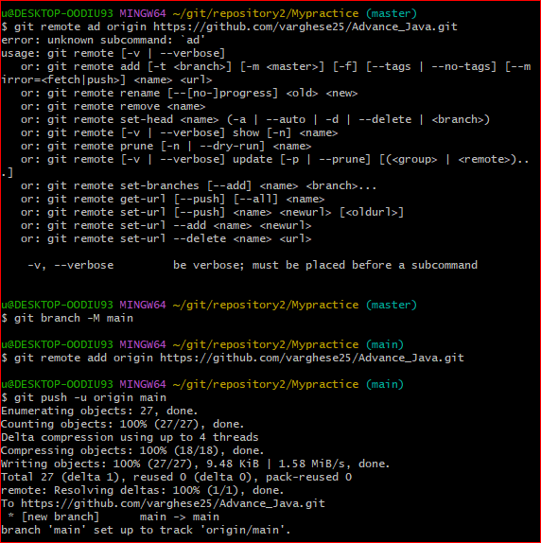

**Git Command**

**git init**

**git add README.md**

**git commit -m "first commit"**

**git branch -M main**

**git remote add origin** [**https://github.com/varghese25/Advance_Java.git**](https://github.com/varghese25/Advance_Java.git) **(Git URL)**

**git push -u origin main**

**Video Reference:**https://www.youtube.com/watch?v=4qZnE49mUH8&t=340s

**Prepared on 18-07-2024  
Prepared by Varghese Baby**